2019 Exam

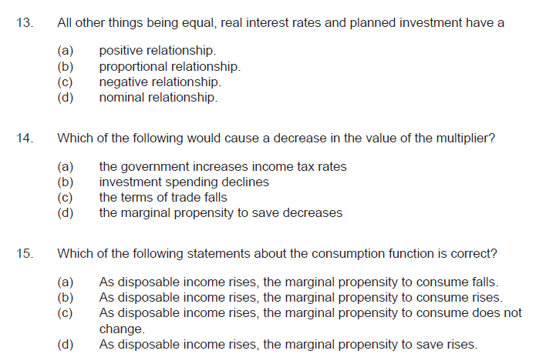

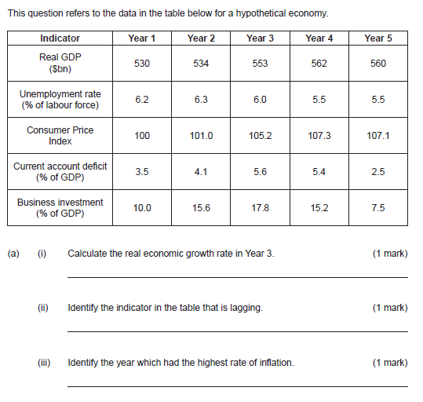

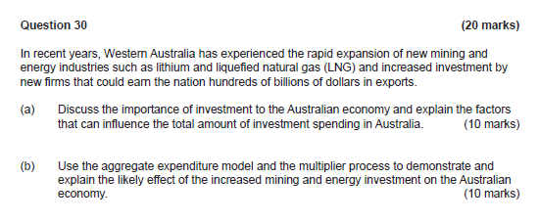

2018 exam

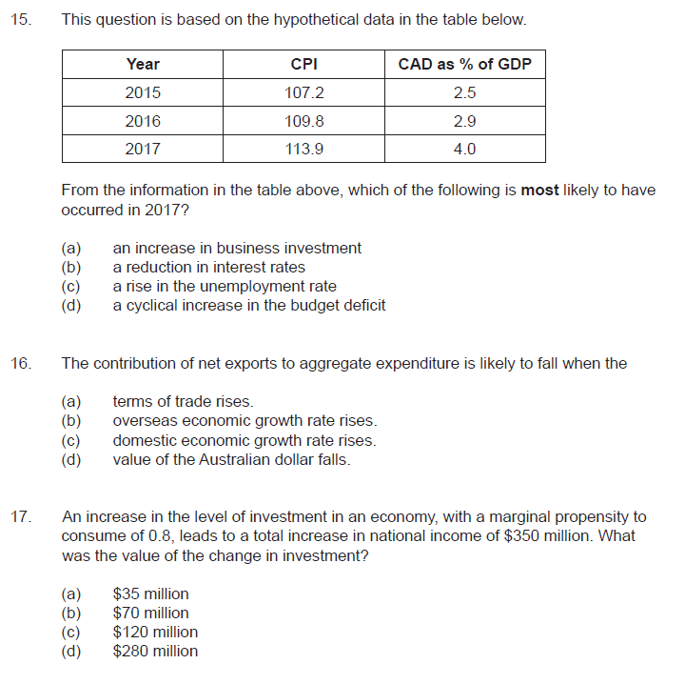

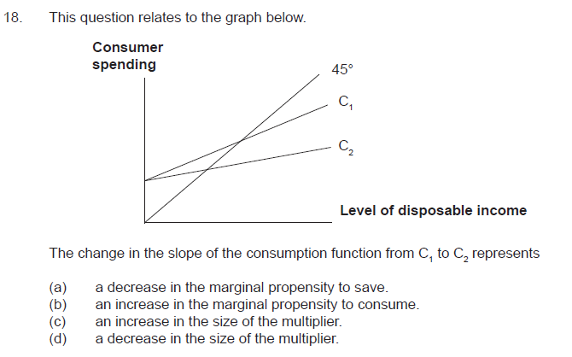

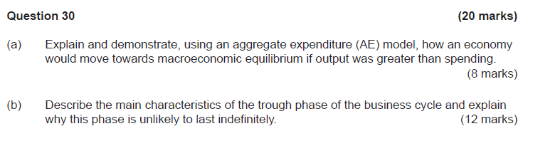

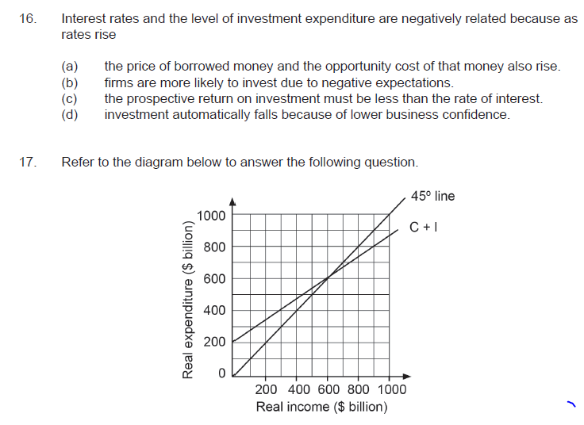

**question 30 Nicole a)**

**explain and demonstrate, using an aggregate expenditure model (AE), how an economy will move towards the macroeconomic equilibrium if output was greater than spending.**

aggregate expenditure describes the amount of money circulating in an economy at any given time. There are four key components that make up this model:

* consumption
* investment
* government expenditure
* net exports

These components add up to the total amount of money in the economy.

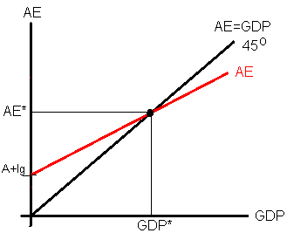

when output is greater than spending, it is the point to the right of equilibrium where people are saving more than they are consumer. In this area, inventories are high because businesses are producing more than people are spending and consuming their goods or services.

Because businesses are producing efficiently and when their inventories are high they have to somehow decrease their levels of efficiency and therefore they produce less. by producing less, inventories decrease and it shifts the curve back to the point of equilibrium.

30B - Jack)

The Business Cycle is the natural growth and shrinking of an economy over time as factors influence a decrease and increase of production (as measured by GDP) in the economy.

The trough of a business cycle is the lowest point in the business cycle and refers to the lowest point in the growth of the economy. A trough is the lowest point and as such is followed by an upswing - growth to an economy.

Characteristics of a trough in the business cycle include;

* Cyclical and Structural UnN @ max
* Frictional UnN @ Min
* Int/R @ Min
* Business & Consumer Confidence @ Min
* Home Approvals @ Min

2/6

The fact that interest rates are low and structural change is at its highest both employment and domestic investment increases forcing a natural growth in the market and causing an upswing. The lower the interest rate means lesser opp cost to use credit increasing consumption in GDP. Investment also increases due to assets being bought with loans on lower interest rates. Government spending is at a high due to transfer payments as the UnN rate is at its greatest. Exports are likely to increase compared to imports as both the price of imports increase due to a drop in exchange rate and a lesser in the willingness and ability to buy imports from consumers while exports are bought as they are cheaper thanks to lesser exchange rates. This naturally forces the GDP to increase as all factors in the AE function increase (AE =C + I + G + (X-M)).

3/6

5/12